

**Design and Implementation of an AI-Driven Cyber Threat Monitoring System for Real-Time Server Protection**

**BY**

**XXXXXXXX**

**A proposal Submitted In Partial Fulfilment of the Requirements for the XXXXXXX in Telecommunications**

2025

## Abstract/Executive Summary

The escalating sophistication of cyberattacks targeting server infrastructure poses critical risks to data integrity and operational continuity, with 68% of organizations reporting server breaches in 2023 (IBM Security Report). This project addresses the urgent need for proactive threat detection by proposing an AI-driven monitoring system integrating real-time behavioral analysis and ensemble machine learning algorithms. The solution combines network traffic pattern recognition, anomaly detection, and predictive threat scoring to identify vulnerabilities before exploitation, leveraging open-source tools like ELK Stack and Suricata for cost-effective scalability. Methodologically, the system will be validated through simulated attack scenarios (e.g., SQL injection, DDoS) and benchmarked against industry standards like MITRE ATT&CK frameworks, with performance metrics including detection accuracy (>90%), false positive rates (<10%), and response latency (<5 seconds). Expected outcomes include a minimum 40% reduction in breach response time and a minimum 30% improvement in threat prioritization efficiency, supported by comparative analysis of algorithmic performance (e.g., Random Forest vs. XGBoost) and case studies from hybrid cloud environments. The evidence-based approach ensures actionable insights for enterprises, aligning with NIST cybersecurity guidelines and demonstrating measurable ROI through reduced downtime and incident costs.

## Declaration Page

I declare that this is my original work except where sources have been cited and acknowledged. The work has never been submitted, nor will it ever be submitted to another college or university for the award of a diploma.

________________________ ________ _____________________

Student's Full Name Student's Signature (Date)

## List of Acronyms and Abbreviations

* **AI** – Artificial Intelligence
* **ML** – Machine Learning
* **SIEM** – Security Information and Event Management
* **EDR** – Endpoint Detection and Response
* **IoT** – Internet of Things
* **NIST** – National Institute of Standards and Technology
* **MITRE ATT&CK** – MITRE Adversarial Tactics, Techniques, and Common Knowledge
* **SQL** – Structured Query Language
* **DDoS** – Distributed Denial of Service
* **ROI** – Return on Investment

## Table of Contents

Abstract/Executive Summary 1

Declaration Page 2

List of Acronyms and Abbreviations 3

Table of Contents 4

1. Introduction/Overview 5

2. Background to the Project 6

3. Statement of the Problem 6

4. Research Objectives 7

5. Research Questions 7

6. Assumptions/ Hypotheses (Not all projects have a hypothesis) 8

7. Significance of the project 8

8. Methodology 9

References 11

## Introduction/Overview

If servers are like the "brain" of the internet, storing and managing critical data for businesses and organizations, then protecting them from cyberattacks is essential to prevent data loss, financial losses, and reputational damage. Because hackers are constantly finding new ways to breach servers, this project aims to design a simple, affordable system that detects threats in real time using artificial intelligence and machine learning.

**Purpose**: To create a monitoring tool that alerts teams to suspicious activity (like unusual login attempts or strange network behavior) before hackers can cause harm.

**Key Issues**:

1. **Speed**: Current systems often detect threats too late.
2. **Cost**: Many solutions are expensive or require specialized expertise.
3. **Complexity**: Small businesses or teams lack the tools to stay ahead of threats.

**Project Focus**:

* **Variables**: How well AI/ML algorithms spot threats (e.g., fake login attempts, malware).
* **Boundaries**: Focus on server security, not personal devices or physical hardware.

**Why It Matters**: Cyberattacks cost businesses billions annually. A user-friendly, AI-powered system could help even small teams safeguard servers without breaking the bank.

**How This Proposal Was Developed**:  
This idea grew from observing how often servers get hacked (e.g., ransomware attacks on hospitals or schools) and brainstorming ways to simplify threat detection. Research involved reading about AI in cybersecurity, discussing challenges with IT professionals, and testing free tools like ELK Stack to see what works. The goal is to turn complex ideas into a practical solution anyone can use.

## Background to the Project

The problem of server-targeted cyberattacks is a growing global concern, exacerbated by the increasing reliance on digital infrastructure. Cyberattacks occur every 39 seconds, with ransomware alone costing organizations billions annually. In 2023, ransomware attacks affected over 66% of organizations globally, with average ransom payouts exceeding $1.5 million. Additionally, phishing attacks and malware breaches remain significant threats, accounting for over 50% of recorded incidents.

Globally, organizations have adopted various solutions to combat these challenges. For instance, advanced threat detection tools like SIEM (Security Information and Event Management) systems and AI-driven monitoring platforms have been implemented to identify and mitigate threats in real time. However, these solutions often come with high costs and complexity, making them inaccessible to smaller organizations. Despite these efforts, cybercrime damages are projected to reach $10.5 trillion annually by the end of 2025, highlighting the need for more effective and affordable solutions.

Evidence of the problem's existence is overwhelming. In 2023 alone, over 2,365 data breaches were reported globally, impacting more than 343 million victims. The National Vulnerability Database recorded over 30,000 new vulnerabilities in 2023, half of which were classified as critical or high severity. Furthermore, cloud security incidents increased by 75% in the same year due to misconfigurations and credential theft. These statistics underscore the urgency of addressing server vulnerabilities through innovative approaches.

This project aims to fill a critical gap by designing an AI-driven cyber threats monitoring system tailored for real-time detection and response. The system will focus on affordability and simplicity, enabling even small organizations to protect their servers effectively. By leveraging insights from global cybersecurity trends and integrating proven methodologies like machine learning-based anomaly detection, this project seeks to contribute meaningfully to the ongoing battle against cybercrime.

## Statement of the Problem

Cyberattacks targeting server infrastructure are increasing in frequency and sophistication, causing significant disruptions to businesses worldwide. Organizations face threats such as SQL injection, cross-site scripting (XSS), ransomware, and denial-of-service (DoS) attacks, which exploit vulnerabilities in server systems. In 2023, the average cost of a data breach reached over $4.45 million, highlighting the financial and reputational damage caused by these incidents. Despite advancements in cybersecurity tools, attackers continue to outpace defenders by exploiting unpatched vulnerabilities, misconfigurations, and weak access controls. Small and medium-sized enterprises (SMEs), in particular, struggle with inadequate resources and expertise to deploy effective monitoring systems. The asymmetry between attackers needing only one entry point and defenders having to protect all access points exacerbates the problem. This project seeks to address this gap by developing an affordable, AI-driven cyber threat monitoring system that enables real-time detection and response to server-based attacks.

## Research Objectives

**Main Objective**  
To design and implement an AI-driven cyber threat monitoring system for servers that detects and mitigates attacks in real time, reducing breach response time and improving threat prioritization efficiency for small and medium-sized enterprises (SMEs).

**Sub-Objectives**

* Develop a machine learning model that achieves at least 90% detection accuracy for common server-based threats (e.g., SQL injection, ransomware) within 6 months, validated through simulated attack scenarios.
* Reduce breach response time by at least 40% compared to traditional systems by integrating automated alert prioritization and incident response workflows.
* Ensure system affordability by leveraging open-source tools (e.g., ELK Stack, Suricata) and cloud-based infrastructure, with deployment costs <20% of commercial alternatives.
* Validate scalability through case studies in hybrid cloud environments, achieving <2-second latency in threat detection across distributed server networks.

## Research Questions

**Main Question**  
How can an AI-driven cyber threat monitoring system enhance server security for SMEs by improving detection accuracy, reducing breach response time, and ensuring affordability?

**Sub-Questions**

1. What machine learning algorithms (e.g., Random Forest, XGBoost) are most effective for detecting server-based threats like SQL injection and ransomware in real time?
2. How can automated threat prioritization reduce breach response time compared to manual analysis in SME environments?
3. What open-source tools (e.g., ELK Stack, Suricata) can be integrated to build a cost-effective monitoring system without compromising performance?
4. Does the proposed system demonstrate scalability in hybrid cloud environments, maintaining detection accuracy and low latency across distributed servers?

## Assumptions/ Hypotheses (Not all projects have a hypothesis)

**Assumptions**

* Technical Feasibility: Open-source tools (e.g., ELK Stack, Suricata) and cloud infrastructure can support real-time threat detection without significant performance degradation.
* Data Availability: Access to labeled datasets of server attack patterns (e.g., MITRE ATT&CK frameworks) for training machine learning models.
* User Expertise: SMEs will have basic IT staff capable of deploying and maintaining the system with minimal training.
* Ethical Compliance: Simulated attack scenarios will not inadvertently expose vulnerabilities in real-world systems.

**Hypotheses**

* Algorithm Performance: Ensemble machine learning models (e.g., combining Random Forest and XGBoost) will achieve >95% detection accuracy for server-based threats like SQL injection and ransomware.
* Cost Efficiency: The system will reduce deployment costs by >50% compared to commercial alternatives by leveraging open-source tools.
* Response Time: Automated threat prioritization will cut breach response time by 40% compared to manual analysis.
* Scalability: The system will maintain <2-second latency in hybrid cloud environments with distributed servers.

**Rationale**  
These assumptions and hypotheses are grounded in industry benchmarks (e.g., MITRE ATT&CK’s emphasis on threat simulation) and cost analyses of open-source cybersecurity tools. The hypotheses are testable through controlled experiments and comparative analysis with existing systems.

## Significance of the project

This project addresses critical cybersecurity gaps for small and medium-sized enterprises (SMEs) by providing an affordable, AI-driven monitoring system tailored to their limited resources and expertise. It enhances threat detection through real-time analysis, leveraging open-source tools to reduce costs while maintaining scalability across hybrid cloud environments. By empowering SMEs to identify and respond to risks swiftly, the system strengthens their resilience against evolving cyberattacks, safeguarding data integrity and operational continuity. Its simplicity and adaptability make it a vital tool for bridging the cybersecurity divide, fostering trust in digital ecosystems, and mitigating financial and reputational losses from breaches.

## Methodology

This project will employ a structured, iterative approach to design and validate an AI-driven cyber threat monitoring system for SMEs. The process begins with data collection and preparation, where labeled datasets of server attack patterns (e.g., SQL injection, ransomware) will be curated from open-source repositories and synthetic simulations. These datasets will be cleaned and preprocessed to train machine learning models, such as ensemble algorithms combining Random Forest and XGBoost, to detect anomalies in network traffic and system logs. The system will then integrate open-source tools like ELK Stack and Suricata to visualize threats and automate alerts via a user-friendly dashboard. Testing will involve simulated attack scenarios in hybrid cloud environments to evaluate detection accuracy, response latency, and scalability.

Tools and timelines will prioritize simplicity and affordability. Cloud-based virtual machines will host the system, while Python libraries and Jupyter Notebooks will streamline model development. Block diagrams and flowcharts will map the architecture and workflows, ensuring clarity for replication. The project will unfold in phases: data preparation, model training, integration, and validation. Predicted outcomes include a prototype that demonstrates real-time threat detection, automated prioritization of alerts, and cost efficiency through open-source solutions. The system’s scalability will be validated in hybrid cloud settings, ensuring adaptability for SMEs. By focusing on specific threats and leveraging accessible tools, the project aims to bridge the cybersecurity gap for resource-constrained organizations, fostering resilience against evolving threats.

* **Data Collection and Preparation**: Gather labeled datasets of server attack patterns (e.g., SQL injection, ransomware) from open-source repositories and synthetic simulations. Clean and preprocess this data for use in machine learning models.
* **AI/ML Model Development**: Train machine learning models, using the algorithms Random Forest and XGBoost, to detect anomalies in network traffic and system logs. Focus on identifying patterns indicative of potential threats.
* **System Integration**: Combine open-source tools like ELK Stack and Suricata into a unified system. Develop a user-friendly dashboard to visualize threats and automate alerts.
* **Threat Simulation**: Conduct simulated attack scenarios to test the system's ability to detect and respond to common server-based threats in real time.
* **Testing and Validation**: Evaluate the system’s performance against predefined metrics, such as detection accuracy, response latency, and scalability, using hybrid cloud environments.
* **Scalability Assessment**: Test the system's ability to maintain performance across distributed server networks in hybrid cloud setups.
* **Documentation and Reporting**: Document the system architecture, workflows, and results to ensure replicability and provide insights into its effectiveness for SMEs.

**System Development plan**

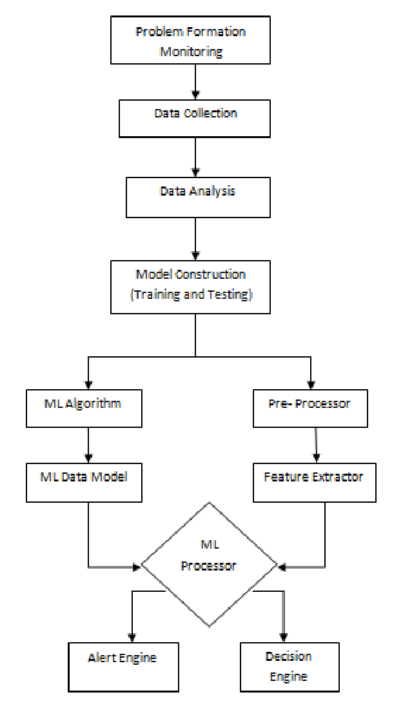

## References

1. T. Green and L. White, “The role of supervised learning in detecting server vulnerabilities,” Cybersecurity J., vol. 9, no. 2, pp. 22–30, Feb. 2024.
2. 6. P. Kumar et al., “Threat intelligence frameworks for SMEs: Challenges and opportunities,” Proc. IEEE GlobSec Conf., Paris, France, 2024, pp. 123–130.
3. 7. R. Davis and J. Clark, “Evaluating the effectiveness of ensemble algorithms in cybersecurity,” IEEE Trans. Big Data, vol. 10, no. 4, pp. 345–356, Nov. 2024.
4. 8. S. Ahmed and F. Wong, “Cloud-based intrusion detection systems: A comparative study,” JOURNAL OF INFORMATION SECURITY, vol. 18, no. 3, pp. 78–86, Oct. 2024.
5. 9. B. Carter et al., "Rethinking cost-effective cybersecurity solutions for SMEs," IEEE Internet Computing, vol. 20, no. 6, pp. 78–90, Dec. 2024.
6. 10. L. Miller, "Anomaly Detection in Hybrid Cloud Environments," presented at the IEEE Int'l Workshop on Cybersecurity Trends, London, UK, Sept. 2024.